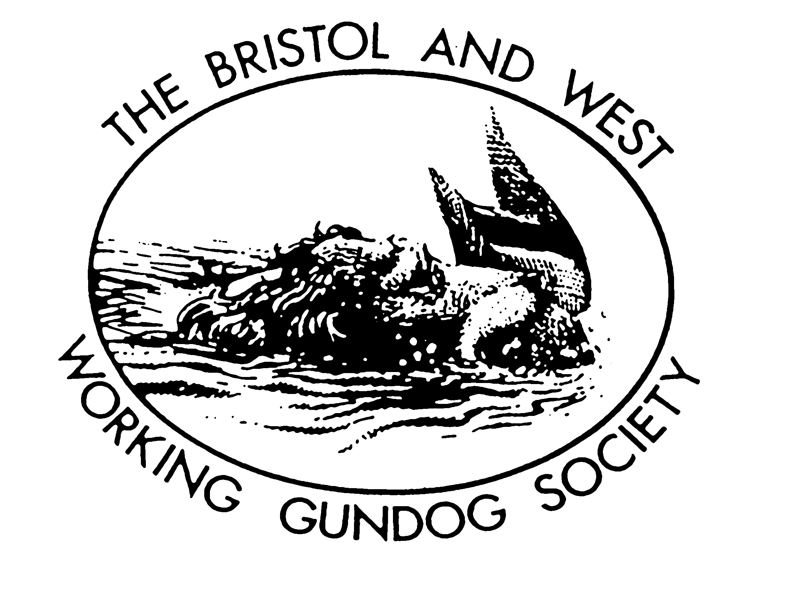

BRISTOL AND WEST WORKING GUNDOG SOCIETY
ID 344
HPR GUNDOG WORKING TEST
Held under Kennel Club Ltd Rules and Regulations

3 July 2021
(CLOSING DATE: 19 June)

Venue: Sholford Farm Huish Champflower Taunton TA4 2HB
By kind permission and support of John and Julia Griffiths

OPEN CLASS: Larry Wilks (A Panel) and Mike Ede AWARD: DORMOND TROPHY
Open to all, although preference may be given to dogs which have gained a place or certificate
of merit at a field trial, been placed first, second or third in an open GWT, or won a novice GWT

NOVICE: Linsey Whitely and Francis Smart AWARD: ASCHFAHL TROPHY
Confined to dogs that have not gained a place or certificate of merit at a field trial, been placed
first, second or third in an Open GWT or first in a Novice GWT held in accordance with KC rules
and Field Trial Regulations

PUPPY CLASS: Christine Carpenter (B Panel) AWARD: TOKI TROPHY
Confined to dogs less than eighteen months old on the day of the test.

WATER: Ian Jones

MEETING TIME: 8.30am for 9.30am start
FEES: £12 Member/£14 Non-Member. 20 maximum entries per class (preference to members)
Cheque payable to: BWWGS
Send To: FT Sec: Ray Davies. 2 Normansland Cottage, Dymock GL18 2BE

Please bring 2 standard green dummies/ Stewards welcome.

RETRIEVING SCURRY with jumps: best winning time wins local food hamper. £1. a-go

LUNCH: Bring your own, hot/cold drinks will be on-site
RAFFLE PRIZES: gratefully accepted

COVID: Legal limits lifted, but safety guidance still apples. BWWGS request you not attend if you have been exposed 14 days prior to the GWT. Certain sensible protocol will still be in place at our events. Hand Sanitizer liquid, mask wearing and social distancing still advised.

SPONSORED BY SKINNERS PETFOODS OF SUFFOLK. 

